**Name: Shruti Verma**

**Roll no: 19115083**

**Semester: VI**

**Subject: Cryptography and Network Security**

**Practical Assignment 3**

1. Write a program to implement the concept of AES algorithm.

**Code :**

// Java program to demonstrate the creation

// of Encryption and Decryption with Java AES

import java.nio.charset.StandardCharsets;

import java.security.spec.KeySpec;

import java.util.Base64;

import javax.crypto.Cipher;

import javax.crypto.SecretKey;

import javax.crypto.SecretKeyFactory;

import javax.crypto.spec.IvParameterSpec;

import javax.crypto.spec.PBEKeySpec;

import javax.crypto.spec.SecretKeySpec;

class AES {

// Class private variables

private static final String SECRET_KEY

= "my_super_secret_key_ho_ho_ho";

private static final String SALT = "ssshhhhhhhhhhh!!!!";

// This method use to encrypt to string

public static String encrypt(String strToEncrypt)

{

try {

// Create default byte array

byte[] iv = { 0, 0, 0, 0, 0, 0, 0, 0,

0, 0, 0, 0, 0, 0, 0, 0 };

IvParameterSpec ivspec

= new IvParameterSpec(iv);

// Create SecretKeyFactory object

SecretKeyFactory factory

= SecretKeyFactory.getInstance(

"PBKDF2WithHmacSHA256");

// Create KeySpec object and assign with

// constructor

KeySpec spec = new PBEKeySpec(

SECRET_KEY.toCharArray(), SALT.getBytes(),

65536, 256);

SecretKey tmp = factory.generateSecret(spec);

SecretKeySpec secretKey = new SecretKeySpec(

tmp.getEncoded(), "AES");

Cipher cipher = Cipher.getInstance(

"AES/CBC/PKCS5Padding");

cipher.init(Cipher.ENCRYPT_MODE, secretKey,

ivspec);

// Return encrypted string

return Base64.getEncoder().encodeToString(

cipher.doFinal(strToEncrypt.getBytes(

StandardCharsets.UTF_8)));

}

catch (Exception e) {

System.out.println("Error while encrypting: "

+ e.toString());

}

return null;

}

// This method use to decrypt to string

public static String decrypt(String strToDecrypt)

{

try {

// Default byte array

byte[] iv = { 0, 0, 0, 0, 0, 0, 0, 0,

0, 0, 0, 0, 0, 0, 0, 0 };

// Create IvParameterSpec object and assign with

// constructor

IvParameterSpec ivspec

= new IvParameterSpec(iv);

// Create SecretKeyFactory Object

SecretKeyFactory factory

= SecretKeyFactory.getInstance(

"PBKDF2WithHmacSHA256");

// Create KeySpec object and assign with

// constructor

KeySpec spec = new PBEKeySpec(

SECRET_KEY.toCharArray(), SALT.getBytes(),

65536, 256);

SecretKey tmp = factory.generateSecret(spec);

SecretKeySpec secretKey = new SecretKeySpec(

tmp.getEncoded(), "AES");

Cipher cipher = Cipher.getInstance(

"AES/CBC/PKCS5PADDING");

cipher.init(Cipher.DECRYPT_MODE, secretKey,

ivspec);

// Return decrypted string

return new String(cipher.doFinal(

Base64.getDecoder().decode(strToDecrypt)));

}

catch (Exception e) {

System.out.println("Error while decrypting: "

+ e.toString());

}

return null;

}

}

// driver code

public class Main {

public static void main(String[] args)

{

// Create String variables

String originalString = "GeeksforGeeks";

// Call encryption method

String encryptedString

= AES.encrypt(originalString);

// Call decryption method

String decryptedString

= AES.decrypt(encryptedString);

// Print all strings

System.out.println(originalString);

System.out.println(encryptedString);

System.out.println(decryptedString);

}

}

**Output :**

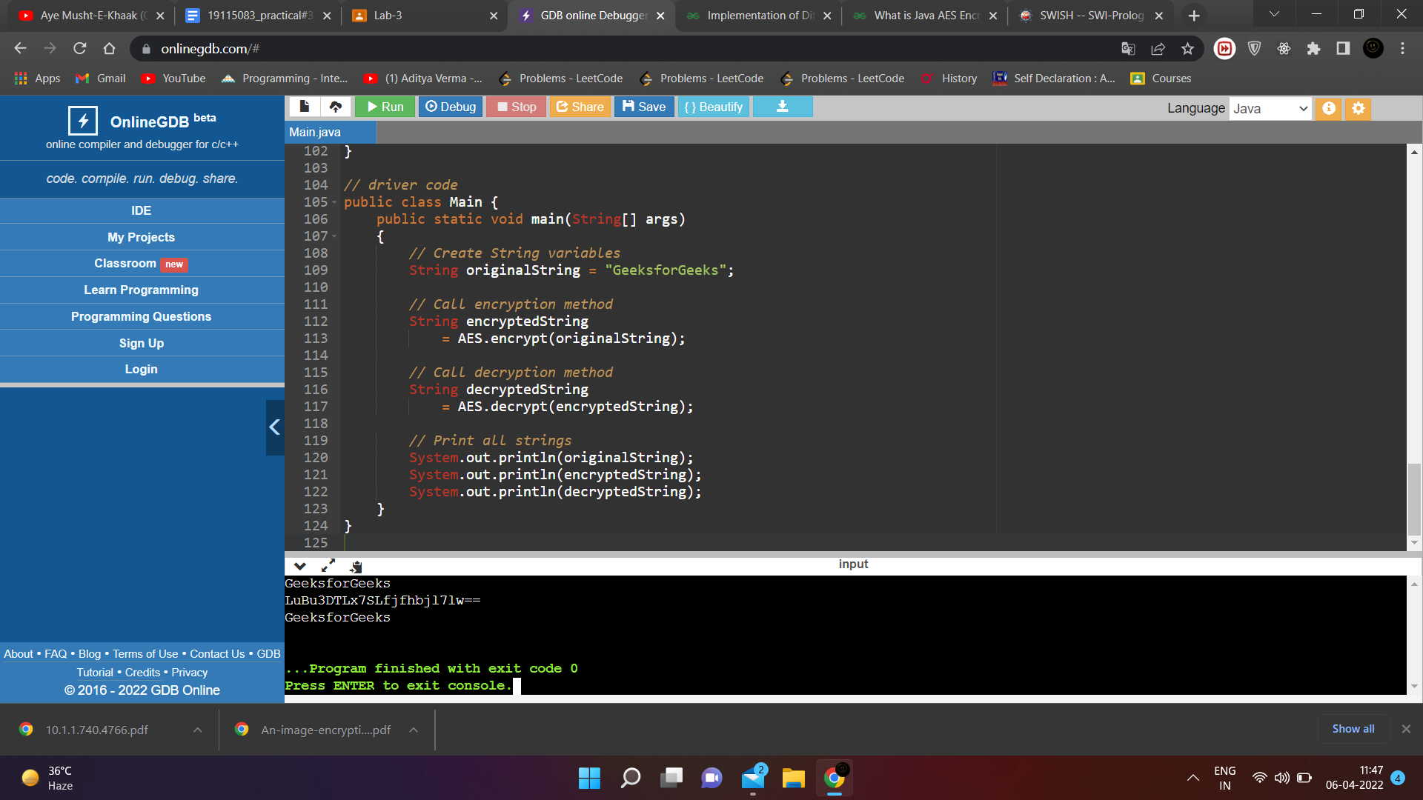

2. Write a program to implement the concept of RSA algorithm..

**Code :**

#include<stdio.h>

#include<math.h>

// Returns gcd of a and b

int gcd(int a, int h)

{

int temp;

while (1)

{

temp = a%h;

if (temp == 0)

return h;

a = h;

h = temp;

}

}

// Code to demonstrate RSA algorithm

int main()

{

// Two random prime numbers

double p = 3;

double q = 7;

// First part of public key:

double n = p*q;

// Finding other part of public key.

// e stands for encrypt

double e = 2;

double phi = (p-1)*(q-1);

while (e < phi)

{

// e must be co-prime to phi and

// smaller than phi.

if (gcd(e, phi)==1)

break;

else

e++;

}

// Private key (d stands for decrypt)

// choosing d such that it satisfies

// d*e = 1 + k * totient

int k = 2; // A constant value

double d = (1 + (k*phi))/e;

// Message to be encrypted

double msg = 324;

printf("Message data = %lf", msg);

// Encryption c = (msg ^ e) % n

double c = pow(msg, e);

c = fmod(c, n);

printf("\nEncrypted data = %lf", c);

// Decryption m = (c ^ d) % n

double m = pow(c, d);

m = fmod(m, n);

printf("\nOriginal Message Sent = %lf", m);

return 0;

}

**Output :**

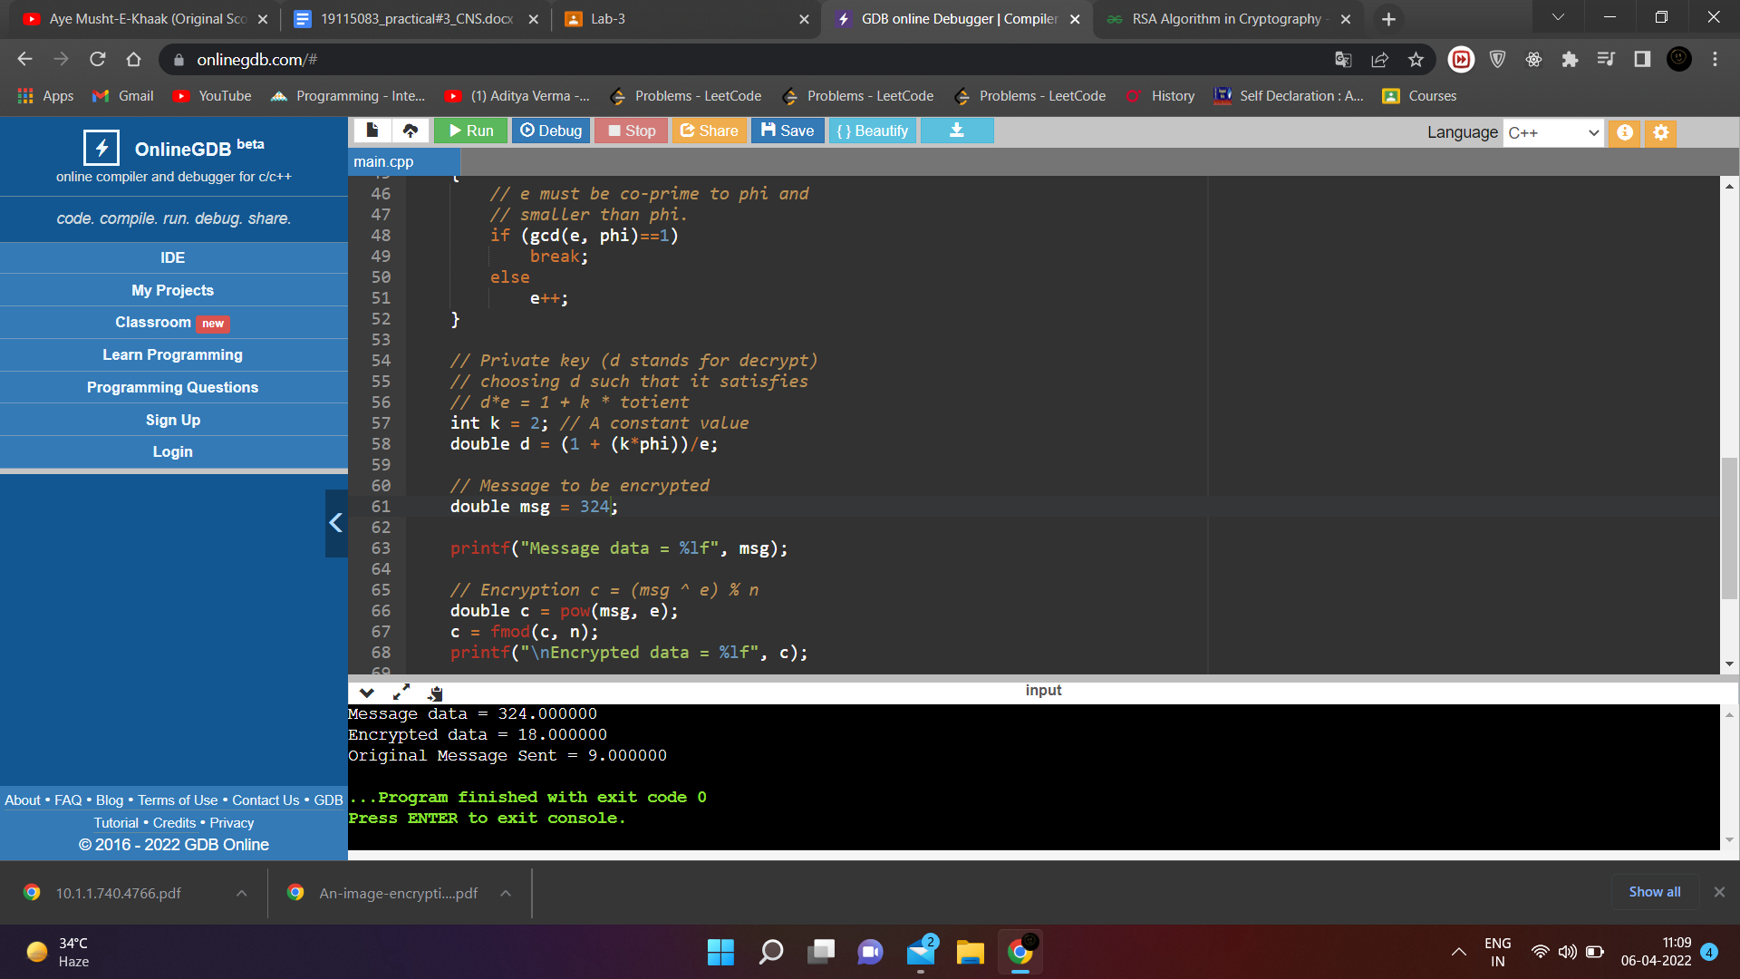

3. Write a program to implement the concept of Diffie-Hellman Key Exchange algorithm..

**Code :**

#include<stdio.h>

#include<math.h>

// Power function to return value of a ^ b mod P

long long int power(long long int a, long long int b, long long int P)

{

if (b == 1)

return a;

else

return (((long long int)pow(a, b)) % P);

}

//Driver program

int main()

{

long long int P, G, x, a, y, b, ka, kb;

// Both the persons will be agreed upon the

// public keys G and P

P = 28; // A prime number P is taken

printf("The value of P : %lld\n", P);

G = 12; // A primitive root for P, G is taken

printf("The value of G : %lld\n\n", G);

// Alice will choose the private key a

a = 4; // a is the chosen private key

printf("The private key a for Alice : %lld\n", a);

x = power(G, a, P); // gets the generated key

// Bob will choose the private key b

b = 3; // b is the chosen private key

printf("The private key b for Bob : %lld\n\n", b);

y = power(G, b, P); // gets the generated key

// Generating the secret key after the exchange

// of keys

ka = power(y, a, P); // Secret key for Alice

kb = power(x, b, P); // Secret key for Bob

printf("Secret key for the Alice is : %lld\n", ka);

printf("Secret Key for the Bob is : %lld\n", kb);

return 0;

}

**Output :**

